**IT2120- Probability and Statistics**

**Lab Sheet 06**

**IT24103034**

1. An IT company claims that their newly developed learning platform improves stu dent performance in online tests. According to previous data, 85% of students who used the platform passed their online tests. A batch of 50 students is selected at random who have completed the course using this platform. Let X denote the number of students who passed the test out of 50 students.
2. **What is the distribution of X?**

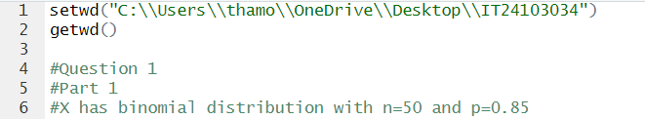

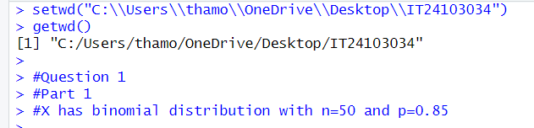

1. **What is the probability that at least 47 students passed the test?**

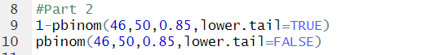

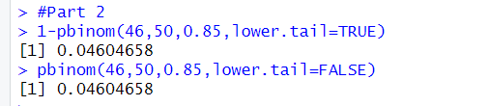

1. **A call center receives an average of 12 customer calls per hour**.
2. **What is the random variable (X) for the problem?**

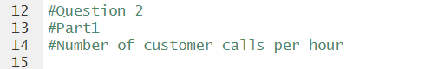

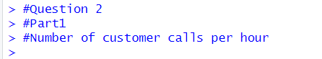

1. **What is the distribution of X?**

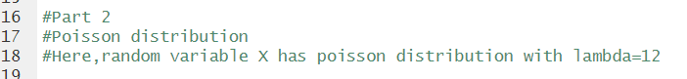

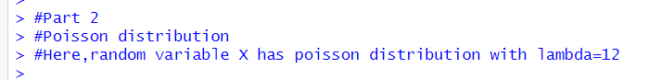

1. **What is the probability that exactly 15 calls are received in an hour?**



